Customer Registration

**#1**

* *Name - Paris*
* *Date-of-Birth-06/01/1996*
* *Address - rock boulevard, 6th avenue*
* *Contact No - 8031996007*
* *Email -* [*manish@gmail.com*](mailto:manish@gmail.com)
* *City - Chennai*
* *State - Tamil Nadu*
* *Pin code – 600119*
* *Identification mark – a mole on elbow*
* *Height – 1.72*
* *Weight – 55*
* *Annual Income - 600000*
* *Currently annually insurance premiums - 10000*
* *Password - Password@123*
* *Confirm Password - Password@123*

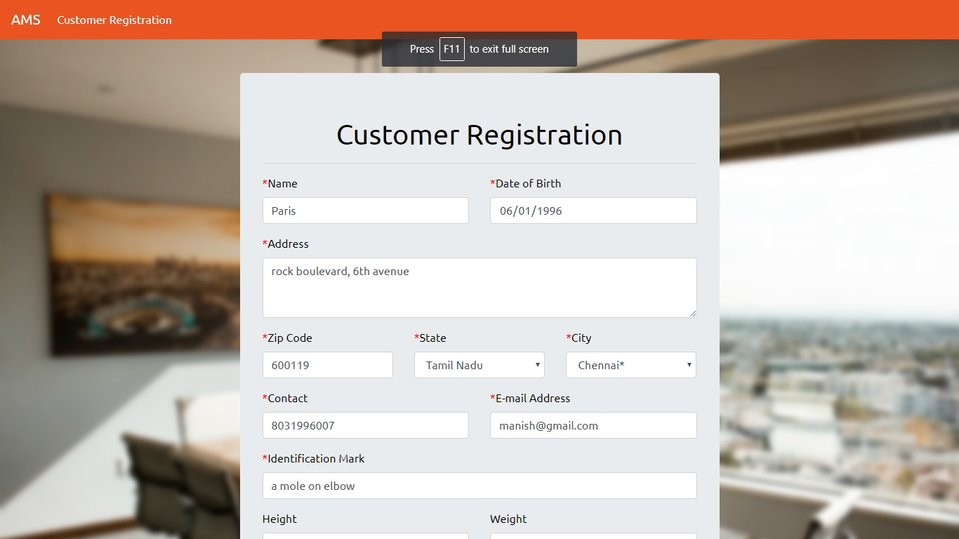

Output –

*Registration Successful*

*You have been successfully registered as a customer. Your login ID is CU0001*

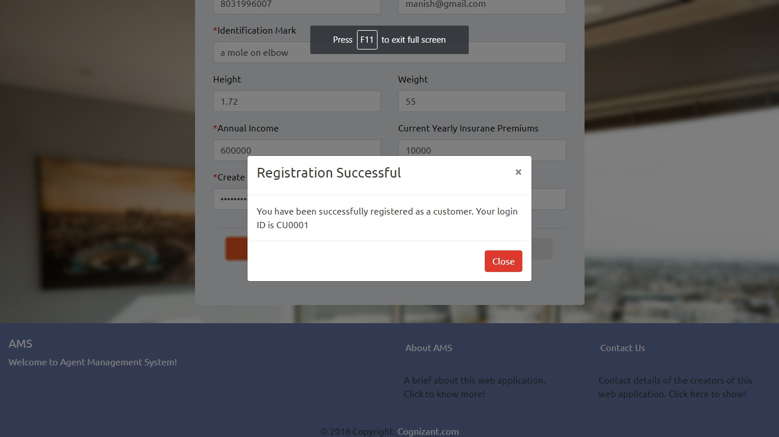

**#2**

* *Name – Jack James*
* *Date-of-Birth-03/05/1980*
* *Address - Jack James Mansion*
* *Contact No - 9089876567*
* *Email -* [*jackjames@gmail.com*](mailto:jackjames@gmail.com)
* *City - Adoor*
* *State - Kerala*
* *Zip code – 867676*
* *Identification mark – None*
* *Height – 1.4*
* *Weight – 60*
* *Annual Income - 7800000*
* *Currently annually insurance premiums - 4000*
* *Password – QWEqwe123*
* *Confirm Password – QWEqwe123*

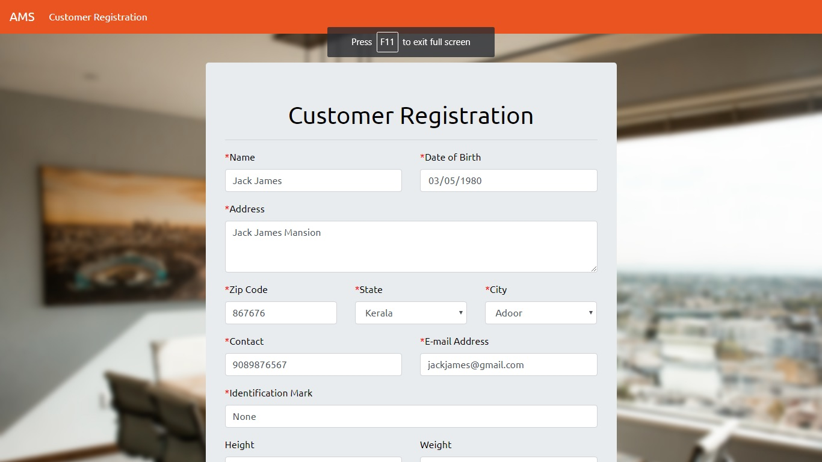

Output –

*Registration Successful*

*You have been successfully registered as a customer. Your login ID is CU0002*

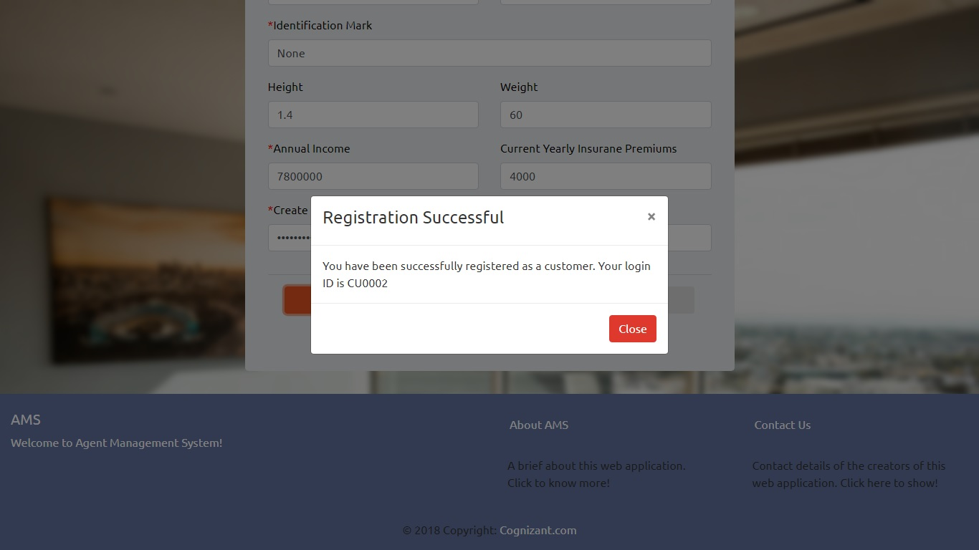

**#3**

* *Name – Paan Singh*
* *Date-of-Birth-03/05/1991*
* *Address - Vasanth Vihar*
* *Contact No - 8787987564*
* *Email – paansingh@hotmail.com*
* *City - Khanna*
* *State - Punjab*
* *Zip code – 987654*
* *Identification mark – Mark on cheek*
* *Height – 1.0*
* *Weight – 78*
* *Annual Income - 5000000*
* *Currently annually insurance premiums - 8000*
* *Password – IOPiop890*
* *Confirm Password – IOPiop890*

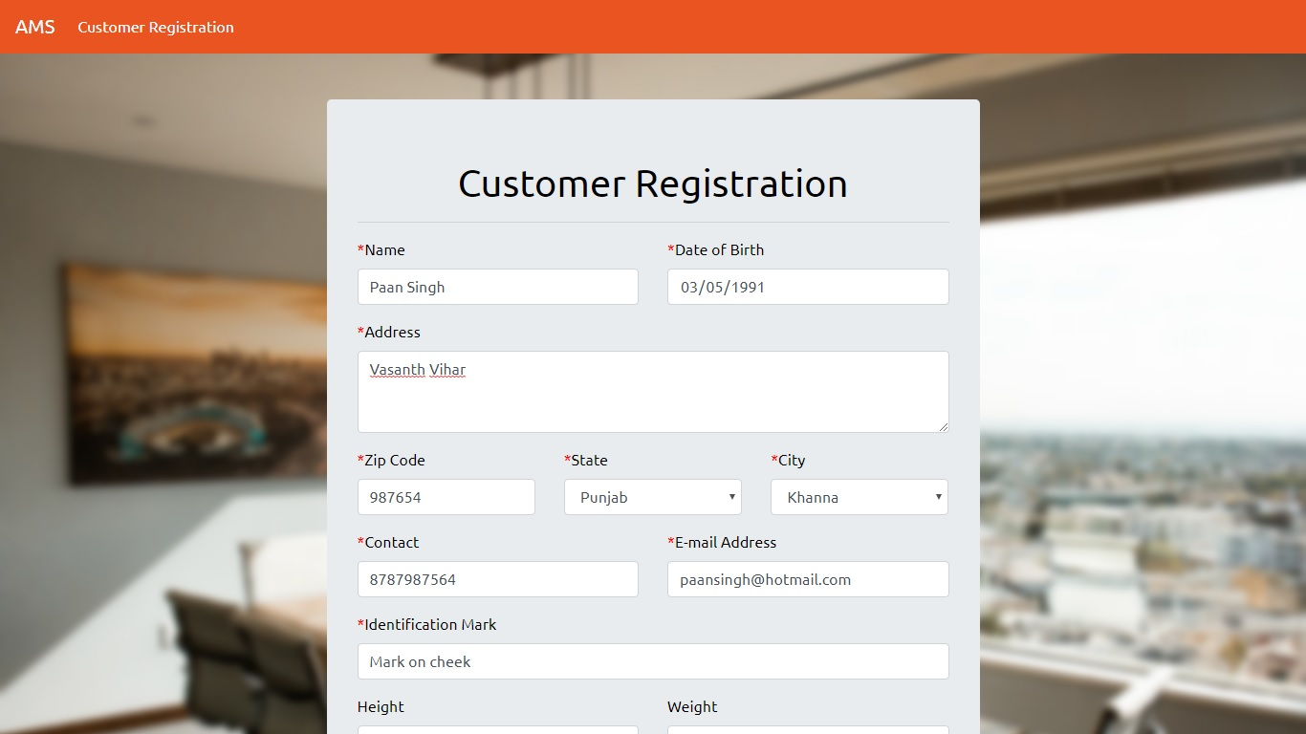

Output –

*Registration Successful*

*You have been successfully registered as a customer. Your login ID is CU0003*

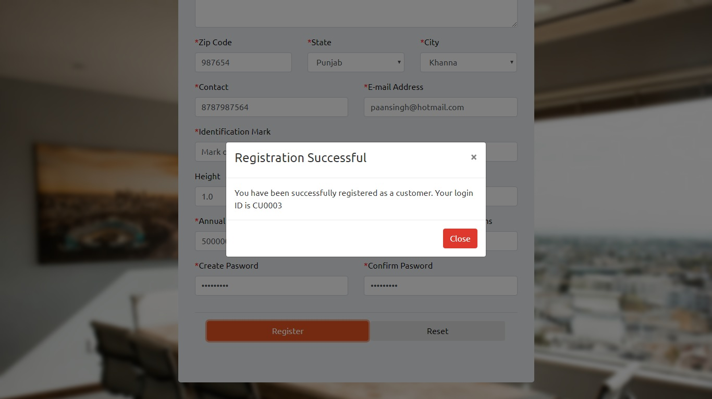

**#4**

* Name – Muralidharan
* Date-of-Birth-03/05/2001
* Address - Murali’s House
* Contact No - 6765654345
* Email – murali@gmail.com
* City - Jammu
* State – Jammu and kashmir
* Zip code – 56565
* Identification mark – Scar on hand
* Height –
* Weight – 99
* Annual Income - 800000
* Currently annually insurance premiums - 8000
* Password – Cognizant1234
* Confirm Password – IOPiop890

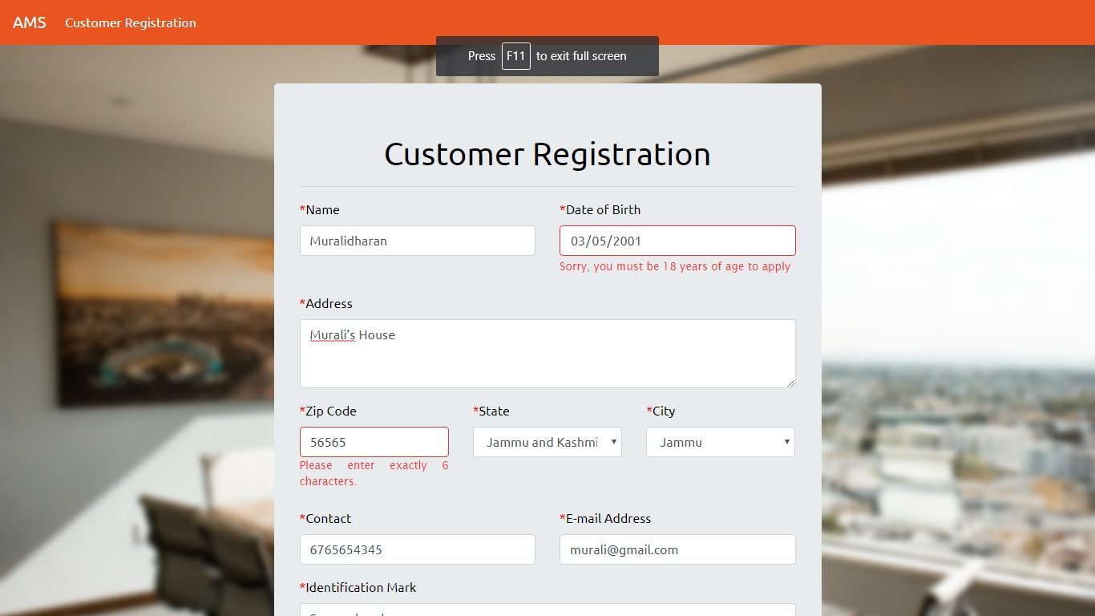

Output –

The following errors are shown below the respective fields:

*Sorry, you must be 18 years of age to apply*

*Please enter exactly 6 characters.*

*Enter the same password again*

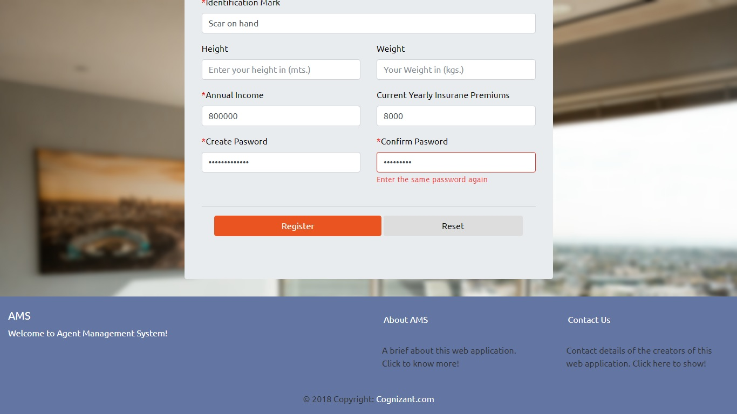

**#5**

* *Name – Muralidharan*
* *Date-of-Birth-03/05/1996*
* *Address - Murali’s House*
* *Contact No - 6765654345*
* *Email – murali@gmail.com*
* *City - Jammu*
* *State – Jammu and kashmir*
* *Zip code – 565656*
* *Identification mark – Scar on hand*
* *Height –*
* *Weight – 99*
* *Annual Income - 800000*
* *Currently annually insurance premiums -*
* *Password – Cognizant1234*
* *Confirm Password – Cognizant1234*

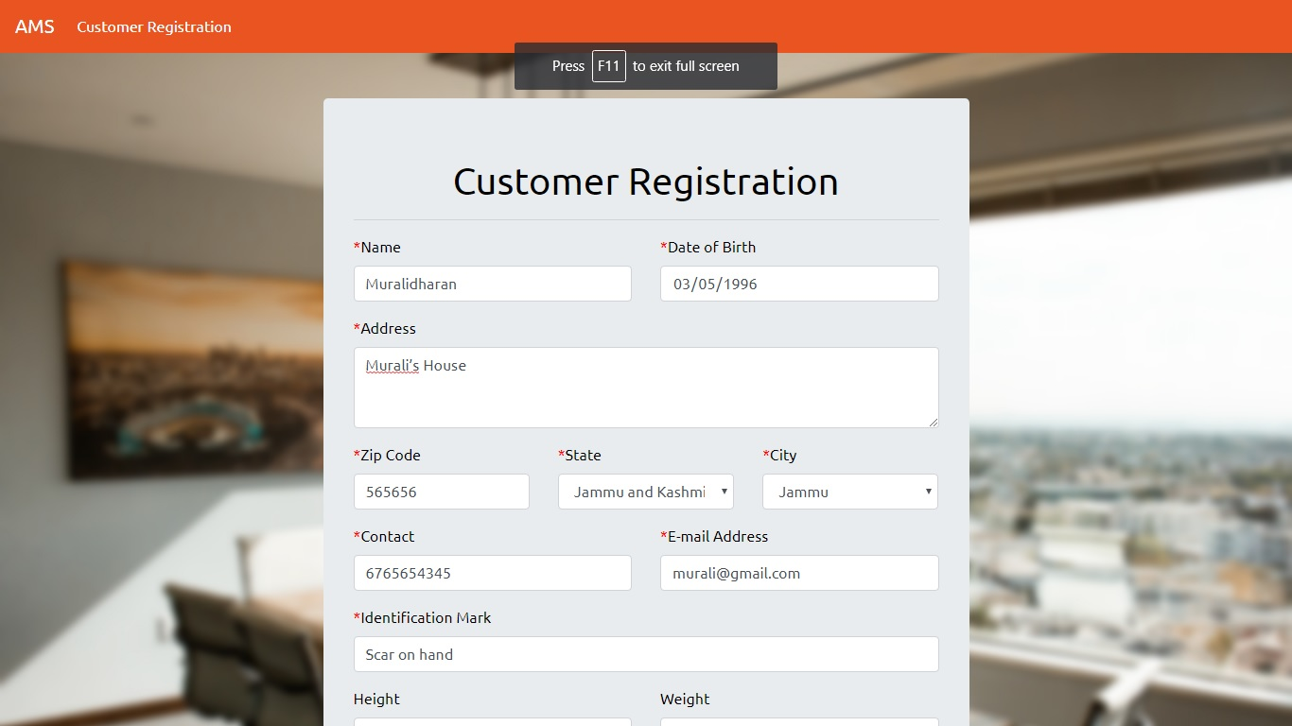

Output –

*Registration Successful*

*You have been successfully registered as a customer. Your login ID is CU0004*

